CKMM -

Functionality
Material price determination calculates the periodic unit price for a material. The standard price and the cumulative single-level differences of the period are taken into account. The material price calculated in multilevel price determination can be used for stock valuation.
The actual cost component split is used to analyze actual costs over multiple production levels.
- Differences from preliminary valuation
- Price differences
- Exchange rate differences
The entered actual costs of a material are listed according to cost components. The original identity of the costs (for example, whether they are material costs or production costs) is retained throughout all production levels.

Scenario
Finished and Semi-Finished Products are valued at standard Price, other materials at valued at Moving Average Price.
This is not a day to day Activity, it is used on ad-hoc basis to change:
- Price control: ‘S’ standard’, ‘V’ moving average.
- Price determination: ‘2’ transaction-based, ‘3’ single-level / multilevel.
The system is configured to default Price determination as “3” Single Level/Multi Level Price Determination for all new material, Price Control as “S” for plants from 5200 to 5213.

Requirements
None.

Menu Path | Accounting → Controlling → Product Cost Controlling → Actual Costing/Material Ledger → Environment → CKMM - Material Price Determination
Transaction Code | CKMM

1. Double Click on CKMM - Material Price Determination

Change Price Determination for Material Ledger

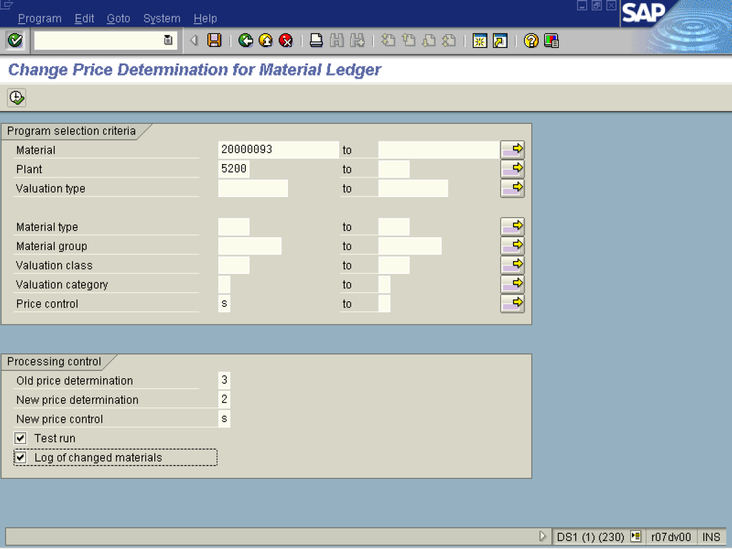

2. Update the following fields:

Field Name | Field Description | Values
Material | Code identifying a product or component | Example: 20000093
Plant | Code identifying the operational unit of the company where the material is manufactured and stored | Example: 5200
Price control | The price control identifies how the material is valuated | Example: S
Old price determination | Specifies how the material price determination should proceed | Example: 3
New price determination | Specifies how the material price determination should proceed | Example: 2
New price control | Indicates the price control used to valuate the stock of a material. | Example: s
3. Click <checkbox> Log of changed materials .
4. Click the Enter button.
Warning

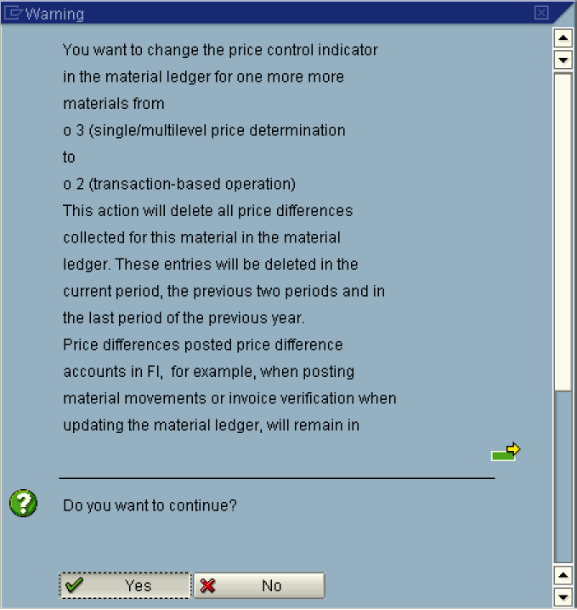
5. Click the Yes Button.
Change Price Determination for Material Ledger

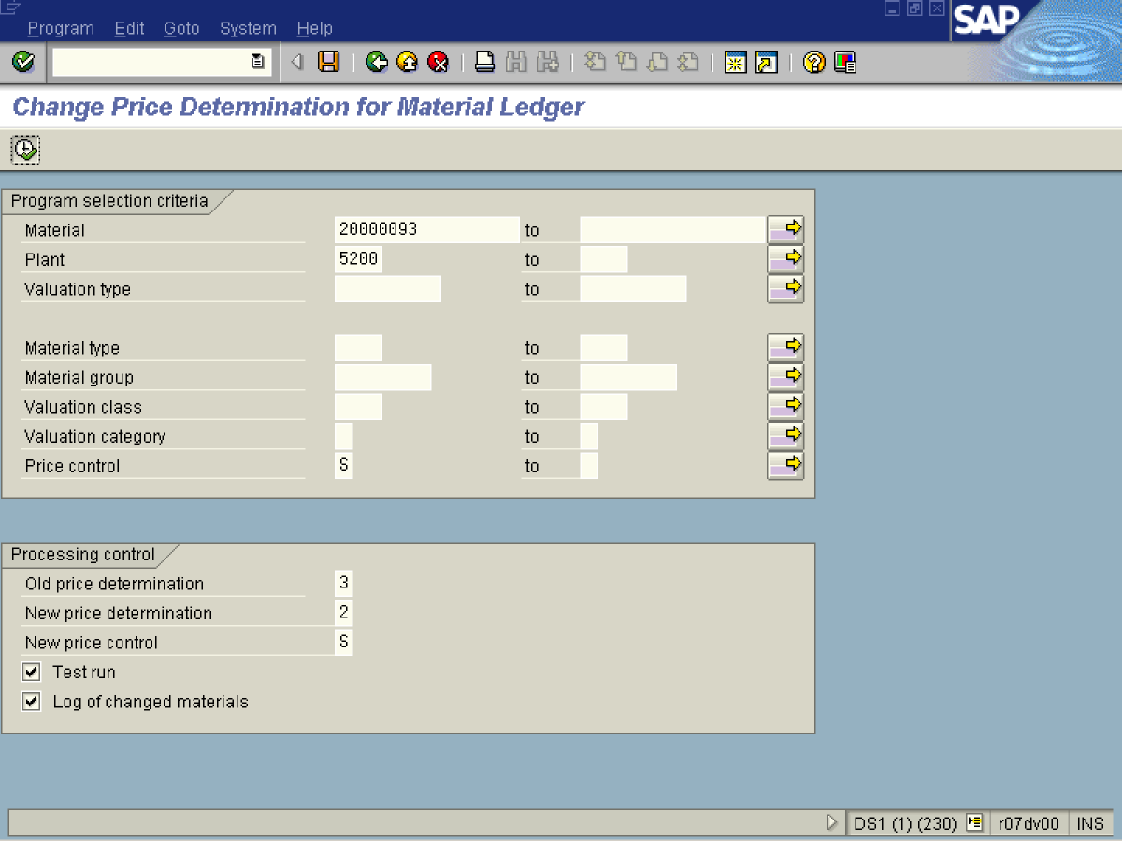

6. Click Execute .
Warning

7. Click the Yes Button.
Change Price Determination for Material Ledger

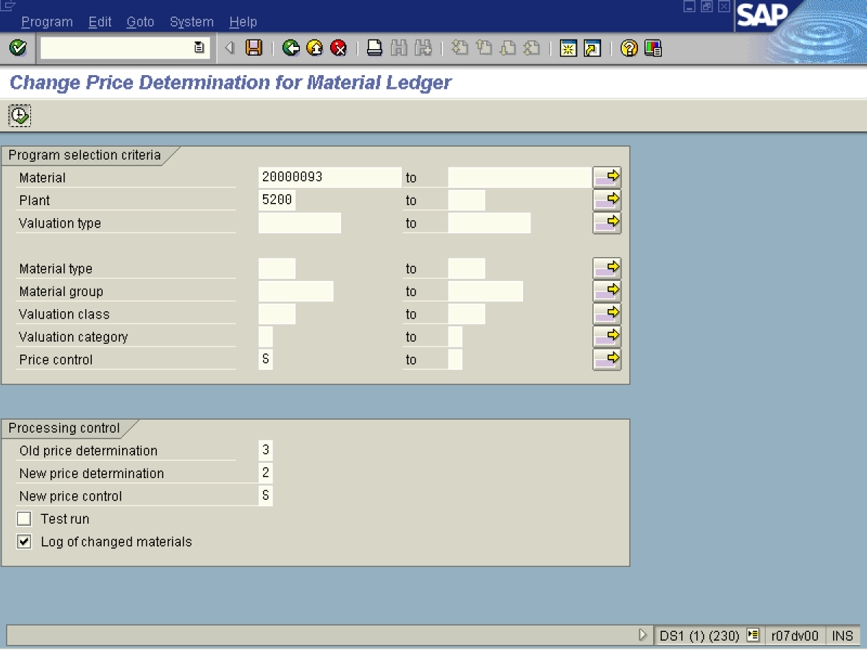
8. Click Back F3 .

9. Click <checkbox> Test run .
10. Click Execute .

Warning

11. Click the Yes Button.
Change price determination for material ledger

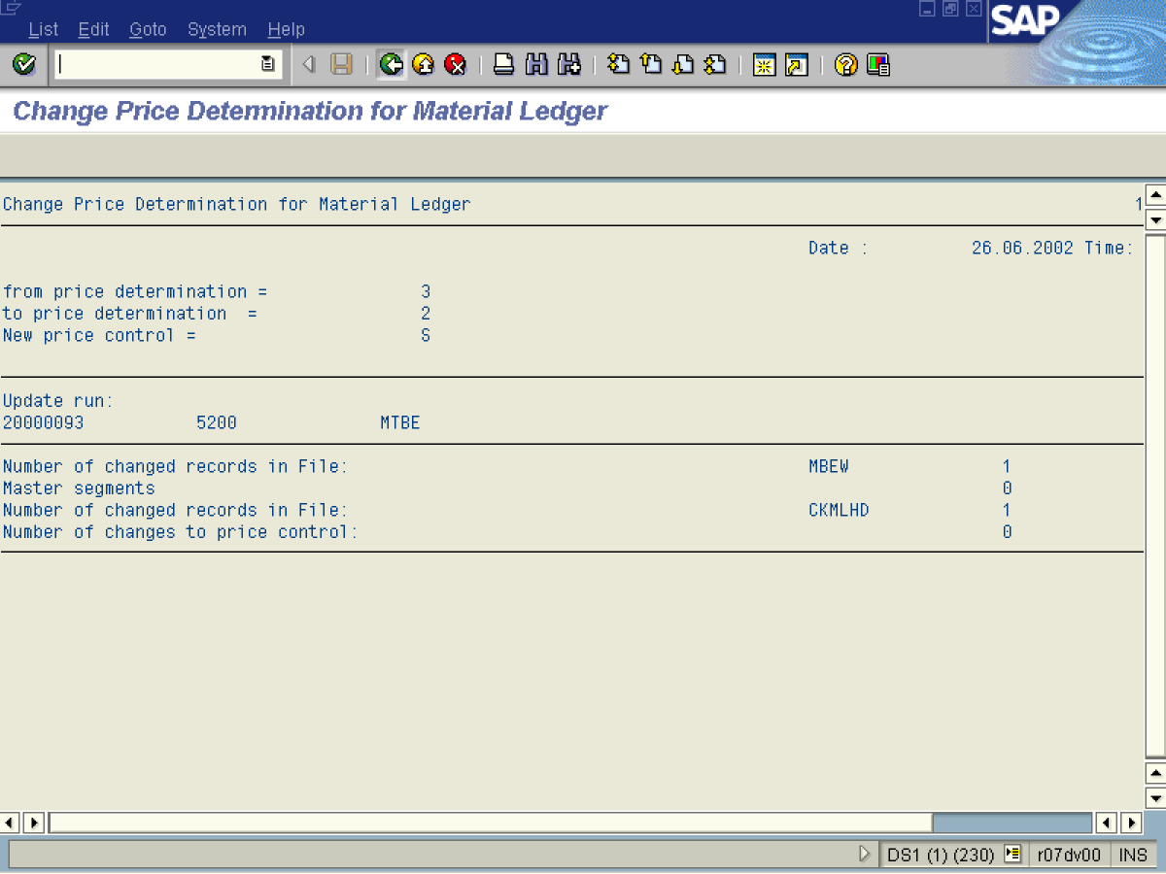

12. The system displays a status log of the transaction.
13. Click Back to exit.

